**Clinical outcomes of orthologous heart transplant after implantation of left ventricular assist devices (LVAD) comparing time to transplant and the use of invasive hemodynamic monitoring**

Background: The optimal characteristics for orthologous heart transplant (OHT) after the implantation of left ventricular assist devices (LVAD) is unknown. There exists significant inter-center variation in the timing of OHT and use of invasive hemodynamic monitoring.

Methods and Results: With the Nationwide Inpatient Sample (NIS) from 1988 to 2011, we identified 2192 patients greater than 18 years of age who underwent implantation of a LVAD and for which day of procedures was available. On average, patients underwent first LVAD placement on day 9.4 of hospitalization and started invasive hemodynamic monitoring 7.4 days prior to LVAD placement. Patients who had invasive hemodynamic monitoring (n = 488, 21.57%) were not significantly different with respect to age (,gender ratio, # of concomitant diagnoses**), however waited longer for LVAD implantation (13.4 days vs. 8.5 days, p < 0.XXX) but had less in-hospital mortality (20.0% vs. 28.5%, p <0.XXX). 164 (7.5%) patients also underwent OHT during the same hospitalization, which occurred 32 days (IQR 7.75 - 66 days) after LVAD implantation. More mortality was seen in patients who underwent OHT within 7 days of LVAD implantation compared to patients who underwent later OHT (25% vs. 13%, p < 0.XXX) as well as compared to patients who did not receive OHT during the same hospitalization (25% vs. X%, p <0.XXX). ***  
  
Conclusions: Mortality is increased for patients who undergo heart transplant within 1 week of LVAD implantation compared to patients who did not receive OHT during the same hospitalization, patients who undergo OHT later during the same hospitalization, and patients who required secondary LVAD placement. Patients who undergo invasive hemodynamic monitoring appear to have better outcomes, however there can be selection bias as these patients could have also been waiting for OHT.

(**) Please add in table of demographic information with/without swan, and verify similarity

(***) There was a population of patients who underwent second/third LVAD placements. Can you also look at thier demographics and % mortality? Maybe we can make the argument if things look bad in first 7 days, better to repeat LVAD than to go to OHT if it's an option.

Table 1: Baseline characteristics

Figure 1:

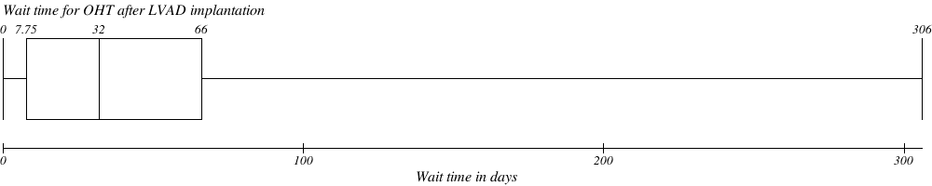

Table 3: